The 6th Annual Mississippi River Cities & Towns Initiative
Capitol Meeting DRAFT Agenda
March 6 – 8, 2018 Washington, DC
Unless otherwise noted, all sessions and events are open to all mayors and other officially invited attendees.
Official functions and meeting services are located in the Phoenix Park Hotel unless otherwise stated.

March 6
Dinner with U.S. Army Corps of Engineers
6:00pm – 9:00pm, Venue TBA
Mayors may gather in the hotel lobby at 5:50pm to travel to dinner venue. Registration materials will be available at the dinner.
Mayors will be joined by leadership from the U.S. Army Corps of Engineers for a sit-down dinner to discuss current challenges facing the Mississippi River as well as possible solutions.
Presiding: George Flaggs, Mayor of Vicksburg, MS
Frank Klipsch, Mayor of Davenport, IA, MRCTI Co-Chair
Lionel Johnson, Mayor of St. Gabriel, LA, MRCTI Co-Chair

Discussion: Major General Richard Kaiser (invited) R.D. James (appointment pending, invited)
Commander, Mississippi Valley Division Assistant Secretary of the Army for Civil Works
U.S. Army Corps of Engineers United States Department of the Army

Edward E. Belk (invited)
Chief, Operations & Regulatory Practice
Directorate of Civil Works
U.S. Army Corps of Engineers

March 7
Mississippi River Valley Investment Fund Development Forum
8:00am – 10:30am, Venue TBA
Join Mayors and Investors from across the finance industry to develop a working Mississippi River Valley Investment Fund that proves resources to cities for near-water natural and built infrastructure project coordinated at corridor scale.
Presiding: Frank Klipsch, Mayor of Davenport, IA, MRCTI Co-Chair
Lionel Johnson, Mayor of St. Gabriel, LA, MRCTI Co-Chair

Introduction: Ambassador Andrew Young
President, Andrew Young Foundation
Former U.S. Ambassador to the United Nations, United States House of
Representatives (GA), Mayor of Atlanta, GA

Presentation: Representative
Finance Industry

Capitol Hill Lunch (Mayors and city staff only)
11:30am – 1:00pm, The Home of Congressman John Delaney, Capitol Hill
Presiding: Frank Klipsch, Mayor of Davenport, IA, MRCTI Co-Chair
Lionel Johnson, Mayor of St. Gabriel, LA, MRCTI Co-Chair

Welcome: The Honorable John Delaney
Member, Financial Services Subcommittee on Housing and Insurance
United States House of Representatives (MD)

Introduction: The Honorable Sharon Weston Broome (invited)
Mayor, City of Baton Rouge, LA

Presentation: Ambassador Andrew Young
President, Andrew Young Foundation
Former U.S. Ambassador to the United Nations, United States House of
Representatives (GA), Mayor of Atlanta, GA

Resilience Roundtable: Achieving Preparedness for Our Cities (Limited space available)
2:00pm – 4:30pm, Woodrow Wilson Center, One Woodrow Wilson Plaza, 1300 Pennsylvania, Avenue, NW
Presiding: Frank Klipsch, Mayor of Davenport, IA, MRCTI Co-Chair
Lionel Johnson, Mayor of St. Gabriel, LA, MRCTI Co-Chair

Session 1: Understanding the Challenge
Welcome: Hon. Roy Buol
Mayor, City of Dubuque, IA

Greetings: Member of Congress
TBA

Introduction: Barbara Hendrie
North America Director
United Nations Environment

Overview: Tonya Graham Laura Hansen
Executive Director Executive Director
Geos Institute EcoAdapt

Session 2: View from the Industry
Greetings: Franklin Nutter
President, Reinsurance Association of America (Washington, DC)

Remarks: Anthony Kuczinski Michael Foley
President & Chief Executive Officer Chief Executive Officer
Munich Re, US (Princeton, NJ) Zurich North America (New York, NY)

Remarks: Samantha Medlock
Senior Vice President, Head of North America Capital, Science & Policy
Willis Towers Watson (Arlington, VA)

Session 3: Way Forward, Moderated Discussion
Moderator: Frederic V. Malek, Founder and Chairman, Woodrow Wilson Center

Break (Return to Hotel)
5:00pm – 6:00pm

Congressional Dinner
6:30pm – 7:00pm, Opening Reception
Mayors may gather in the hotel lobby at 6:15pm to the Dinner venue
Join Davenport Mayor Frank Klipsch, St. Gabriel Mayor Lionel Johnson, and members of the U.S. Senate and House of Representatives for a reception and dinner with the Mississippi River Caucus.

7:00pm – 8:30pm, Dinner
This is our chance to impress upon new members of Congress and the Administration the importance of the Nation’s Inland Waterway System and the valuable Federal Partnerships that can fulfill America’s infrastructure needs.

March 8
Breakfast: MRCTI Mayors’ Business Meeting
8:00am – 9:00am, Phoenix Park Hotel
Presiding: Frank Klipsch, Mayor of Davenport, IA, MRCTI Co-Chair
Lionel Johnson, Mayor of St. Gabriel, LA, MRCTI Co-Chair

Discussion: The Honorable Tim Kabat The Honorable Robert Gallagher
Mayor of La Crosse, WI Mayor of Bettendorf, IA
MRCTI Treasurer MRCTI Secretary

White House Meeting (invited participants only)
10:00am – 11:30am, White House, 1600 Pennsylvania Avenue, NW
Presiding: Frank Klipsch, Mayor of Davenport, IA, MRCTI Co-Chair
Lionel Johnson, Mayor of St. Gabriel, LA, MRCTI Co-Chair

Welcome: President’s Office of Intergovernmental Affairs

Discussion: President’s Special Advisory Team on Infrastructure

Mayors Press Conference
12:00pm, TBD

12:30pm – Adjourn

Hotel Information
Rooms are available at a reduced rate within the historic Phoenix Park Hotel (pictured below), 520 Capitol Street, NW, Washington, DC 20001. Reservations can be made by calling 202-638-6900, ask for the block under Mississippi River Cities & Towns (code 21131).
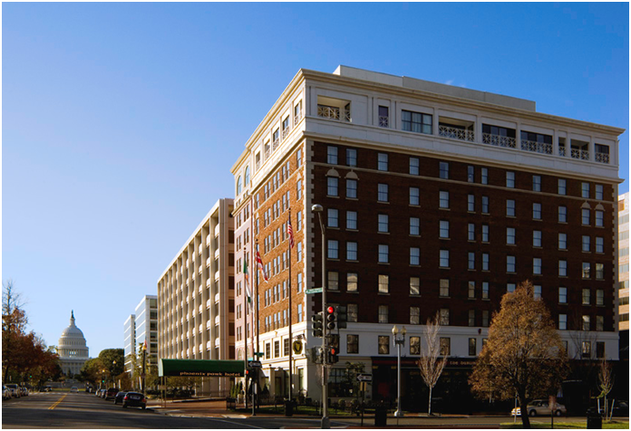
520 North Capitol Street, NW
Washington, DC 20001
p 202.638.6900
f 202.638.4025

